
投標注意事項:
Bidding Documents Submission Notice:

- 請將所有投標文件備妥並密封於信封內。
Please make sure you have all bidding documents ready, and make sure your tender is in a sealed envelope.
- 請將外標封黏在快遞信封外如圖示。
Please paste our cover sheet on the outside of a forwarder’s envelope as below.
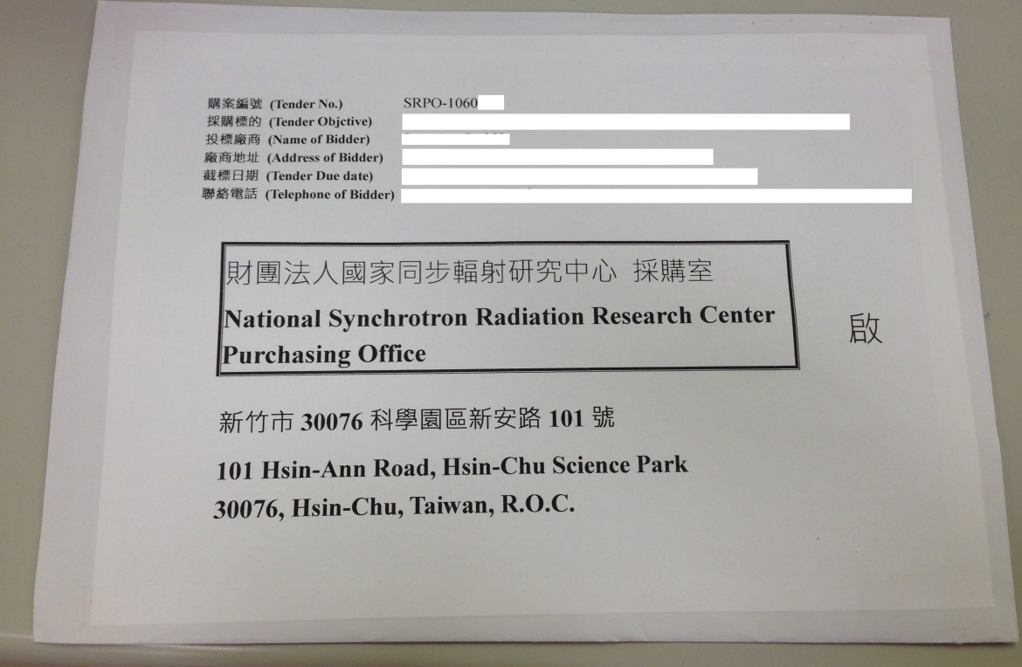
- 本案須檢附以下投標文件:
This required bidding document includes:
■設立登記證明1份
A photocopy copy of certificate of registration or establishment documents of under applicable law in your country
■用印之標價清單1份
An original signed Price List of Tender with your Bid Price
■投標廠商代理人授權書1份
An original “Power of Attorney” signed by company president or CEO
■企劃書3份
Proposal in THREE complete sets, the following items shall be included in your proposal:
審 查 項 目 (Examination Item) | 項 目 說 明  (Description) | 配分(Score)
廠商信譽、履約能力及實績  (Tenderer’s reputation, performance capability and its achievement) | 1.廠商之人力、經營能力、聲譽及財務狀況(Tenderer’s man power, capability of business running, commercial credit and financial condition)  2.提供曾完成與本案類似之承做經驗與實績(Providing tenderer’s contract performance record or similar experience and achievement example)  3.執行本案相關專業技術人力規劃(Providing tenderer’s related professional technical manpower planning)  4.廠商在全球或在台銷售業績與服務狀況(Tenderer’s sale outstanding accomplishment and its after-sales services description) | 10 分
技術規格性能  (Tenderer’s technical specifications, performance) | 1.產品設備內容（含軟、硬體架構或配置、主要配備內容及廠牌名稱）(Tenderer’s product description including its software, hardware structure, allocation, main equipment and manufacture brand)  2.有助於提升本案功能之額外配備等項目說明(How to upgrade its function and its necessary additional equipped item description)  3.產品未來相容、擴充能力，與既有環境及設備之整合情形(Providing product its compatible and expandable capability and how to integrate with current environment and original equipment)  4.對本案之瞭解及所提之技術需求之建議說明(Providing tenderer’s understanding and technical requirement suggestion about this tender) | 30 分
履約品質及管理執行能力(Tenderer’s performance quality and its management capability) | 1工作項目劃分品質內容與保證措施、交付項目與測試時程等規劃(Examine tenderer’s mark off action items and its evaluate quality control description, delivery items and inspection planning)  2.國內外支援體系與技術能力支援說明(International and local technical logistic support description)  ※請留意交期不得晚於契約規範之交期  ※Please note that a bidder should accept NSRRC required schedule, or offer an earlier delivery schedule. | 10 分
價格(Price) | 價格明細及分析(Price list and Cost breakdown) | 40 分

- 請列印「廠商投標文件審查表」並檢附相關文件。
Please fill in company name on page 1 of “Bid Documents Evaluation Form for Tenderer” and enclose the required certificates/documents in order.
- 請於截標前將投標文件送達本中心。
Please submit your documents to NSRRC by closing deadline.

※ 請留意投標文件逾期將不予受理。
Please note a late tender will not be considered.

Kind regards,

Ms. Kate Hsu
Procurement Office
Tel:+886-3-5780281 ext:8406
E-mail address: hsu.tw@nsrrc.org.tw

